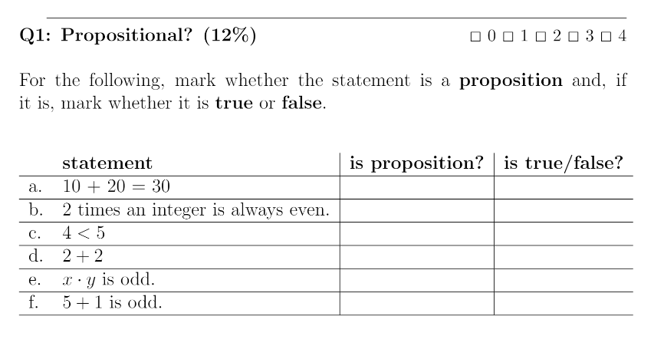

1. Propositional Logic
   1. Yes, True
   2. No, True
   3. Yes, True
   4. No, False
   5. Yes, True
   6. Yes, False

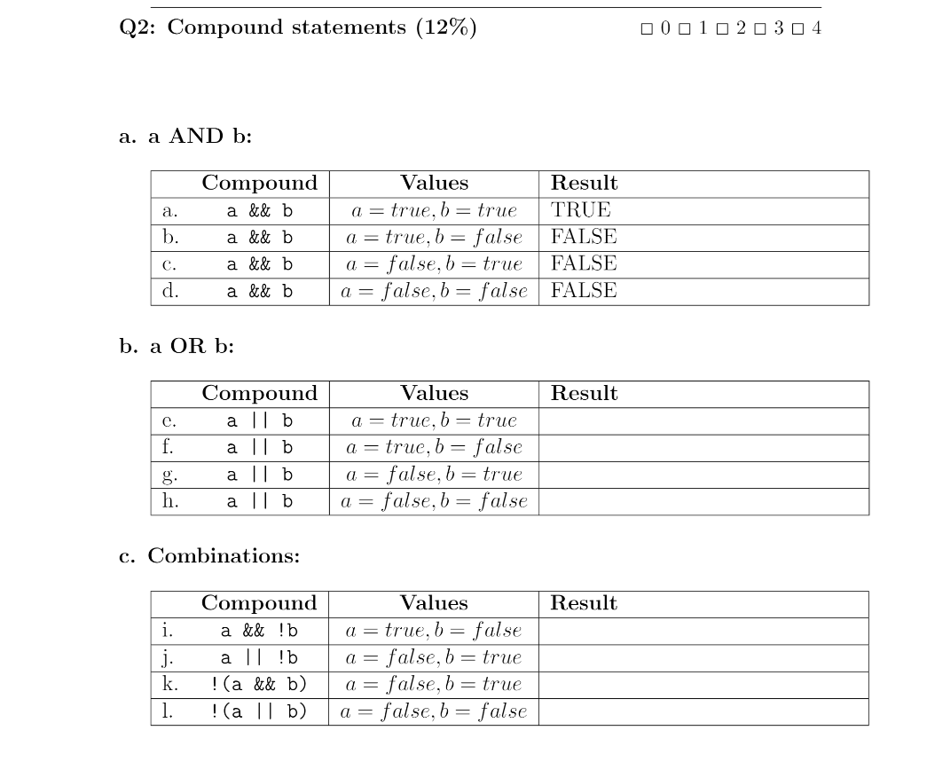

1. a OR b:
   1. True
   2. True
   3. True
   4. False
   5. True
   6. False
   7. False
   8. True

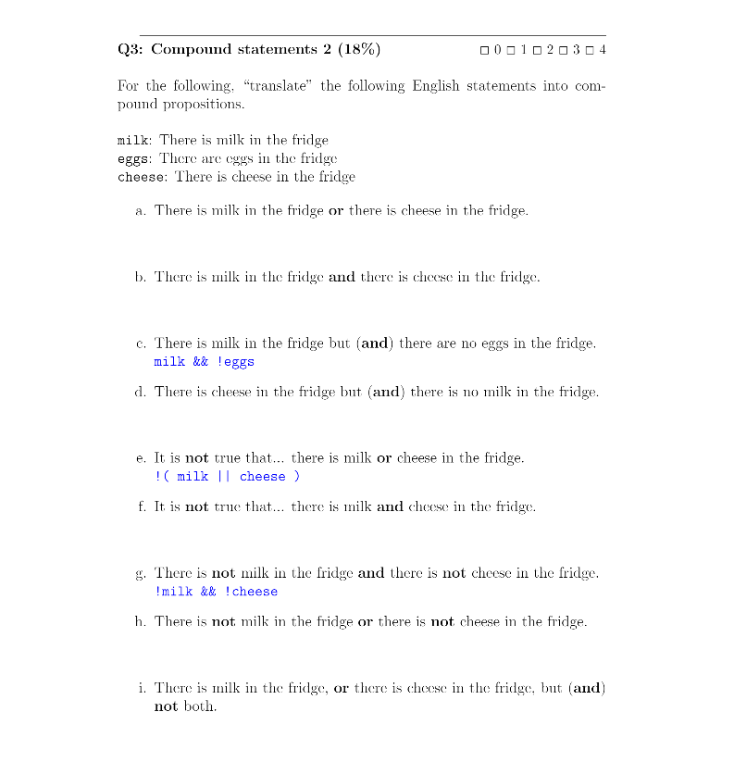

1. Compound Statements
   1. milk || cheese
   2. milk && cheese
   3. n/a
   4. cheese && !milk
   5. n/a
   6. !(milk && cheese)
   7. n/a
   8. !milk || !cheese
   9. (milk || cheese) && !(milk && cheese)

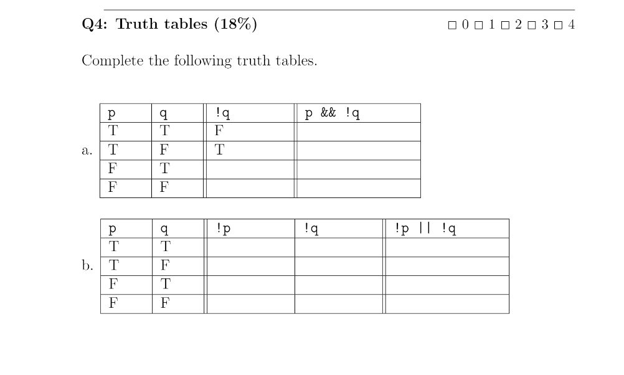

1. Truth Tables
   1. F, F
   2. T, T
   3. F, F
   4. T, F
   5. .
   6. F, F, F
   7. F, T, T
   8. T, F, T
   9. T, T, F

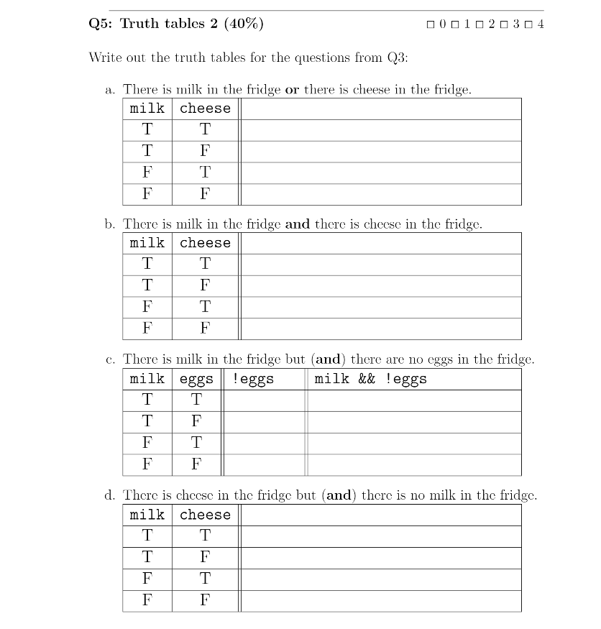

1. Truth Tables 2
   1. T, T, T, F
   2. T, F, F, F
   3. F, F
   4. T, T
   5. F, F
   6. F, F
   7. F, F, T, F

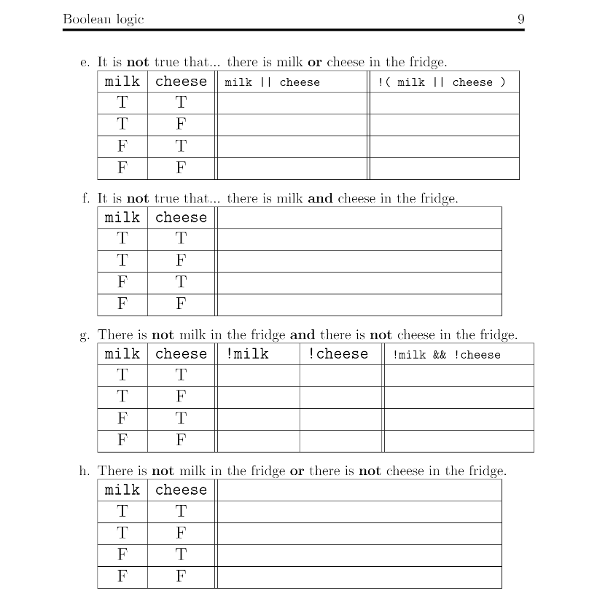

1. T, F
2. T, T
3. T, T
4. F, T
5. F, F, F, T
6. F, F, F
7. F, T, F
8. T, F, F
9. T, T, T
10. F, T, T, T